**Triggering Parameterized Builds**

This section will guide you to:

* Configure parameterized builds
* Trigger a parameterized build remotely via curl
* Trigger a build job based on another job’s results

**Step 1:** Creating a Git repository for the recipe categorization program

* Login to your **Github** account.
* Click on the plus icon next to the profile picture and select ***New repository*** from the drop down menu.

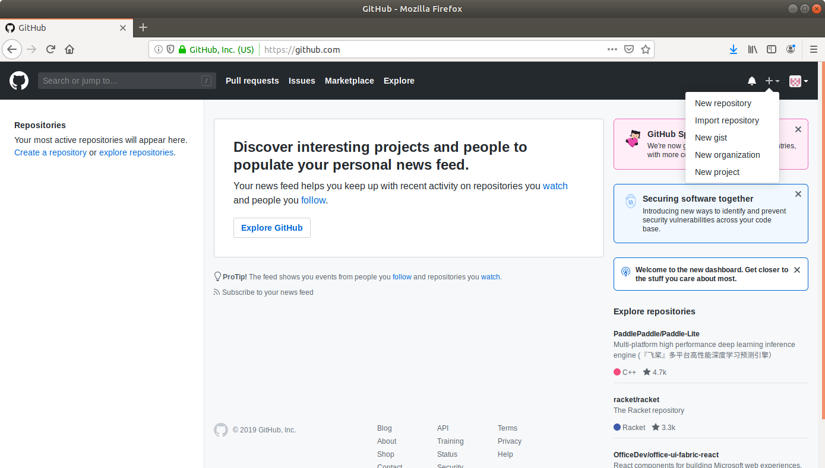

* Fill the required fields in the create repository form.

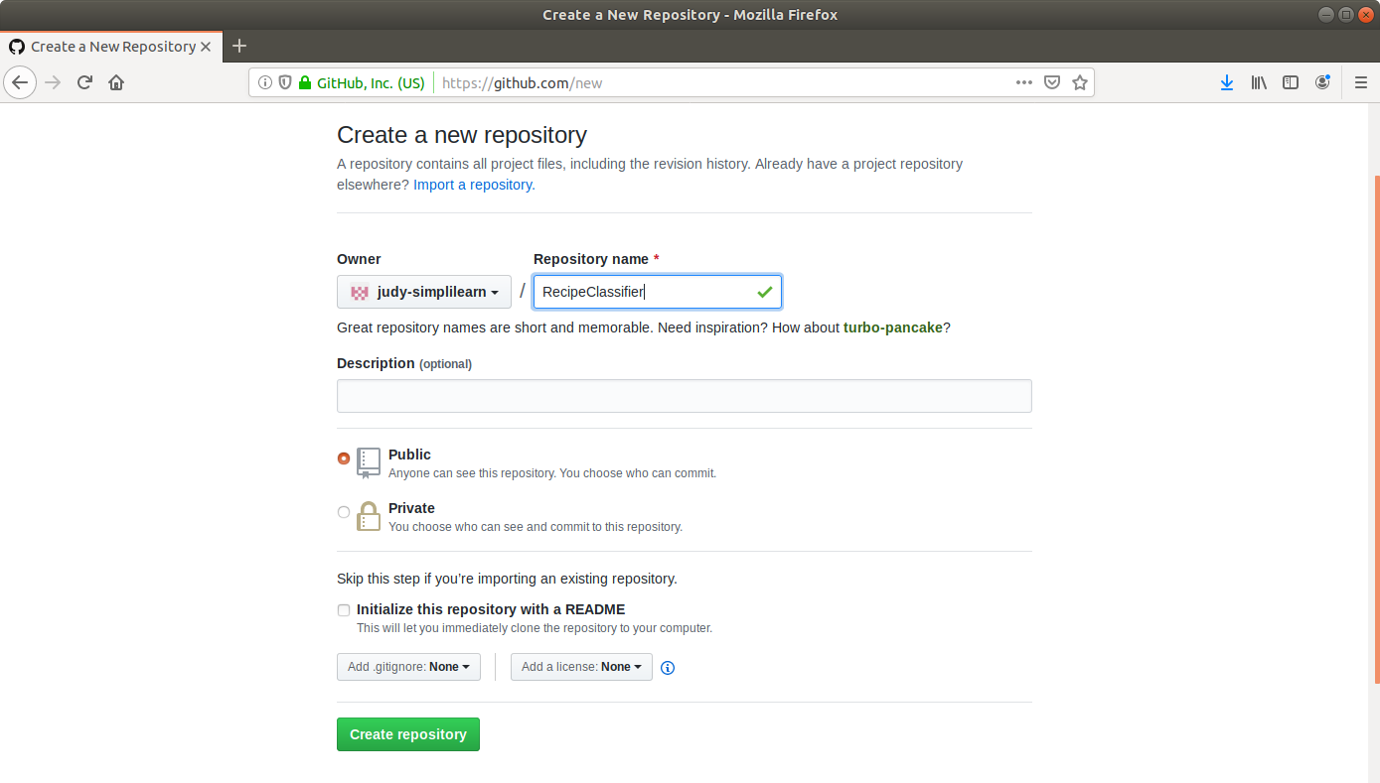

* Click on the **Create Repository** button.

**Step 2:** Adding the code for recipe categorization to the repository

* Open the terminal and navigate to an appropriate location.
* Run **mkdir RecipeClassifier** to create a directory.
* Navigate to the **RecipeClassifier** directory.
* Run **vi Test.java** to open the java file in a text editor.
* Paste the below code into the file.

**import java.util.ArrayList;**

**public class MostRepeatedWord {**

**public static void main (String[] args) {**

**System.out.println("Hello");**

**}**

**}**

* Save the file and exit the text editor.
* Run **git init**
* Run **git add .**
* Run **git commit -m “Add new files”**
* Run **git remote add origin [Repository_URL]**
* Run **git push -u origin master**

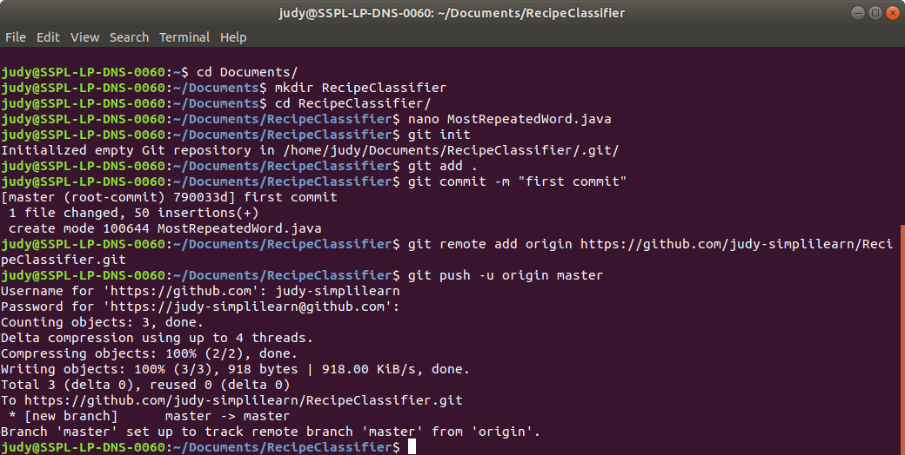

**Step 3:** Creating a parameterized build job in Jenkins to delete temporary files

* Go to Jenkins **dashboard.**
* Navigate to **Manage Jenkins**→ **Manage Plugins**→ **Available.**
* Search for **Build with Parameters Plugin** and click on install without restart.
* From the Jenkins Dashboard, click on ***New Item***.
* Enter a **name** for your build job.
* Select ***Freestyle project***as the build job type.

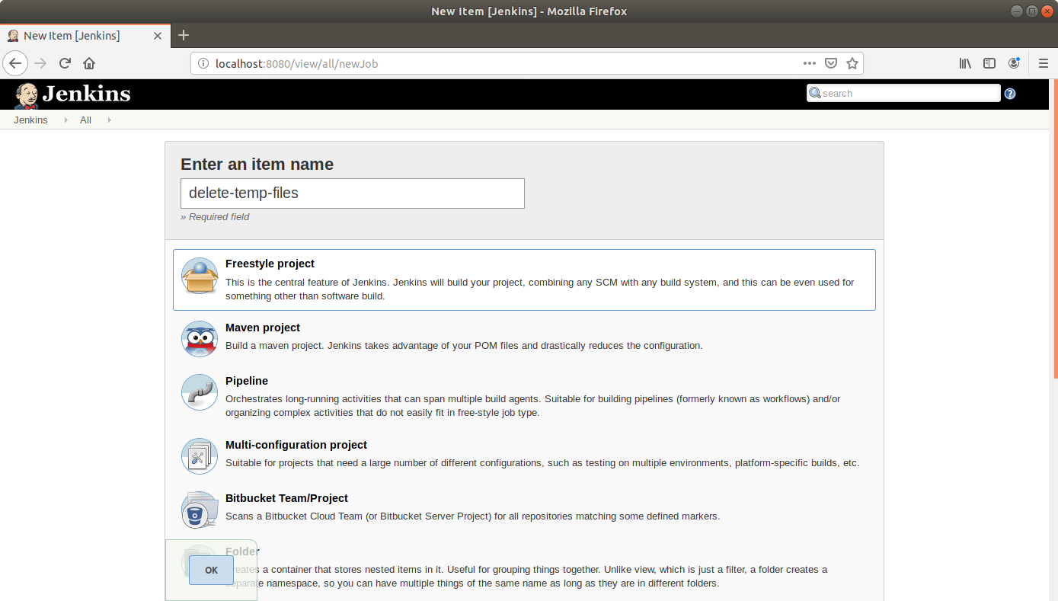

* Click **OK**.
* On the configuration page, select the checkbox next to text that states,***This project is parameterized*.**
* Click on the ***Add parameter*** button.

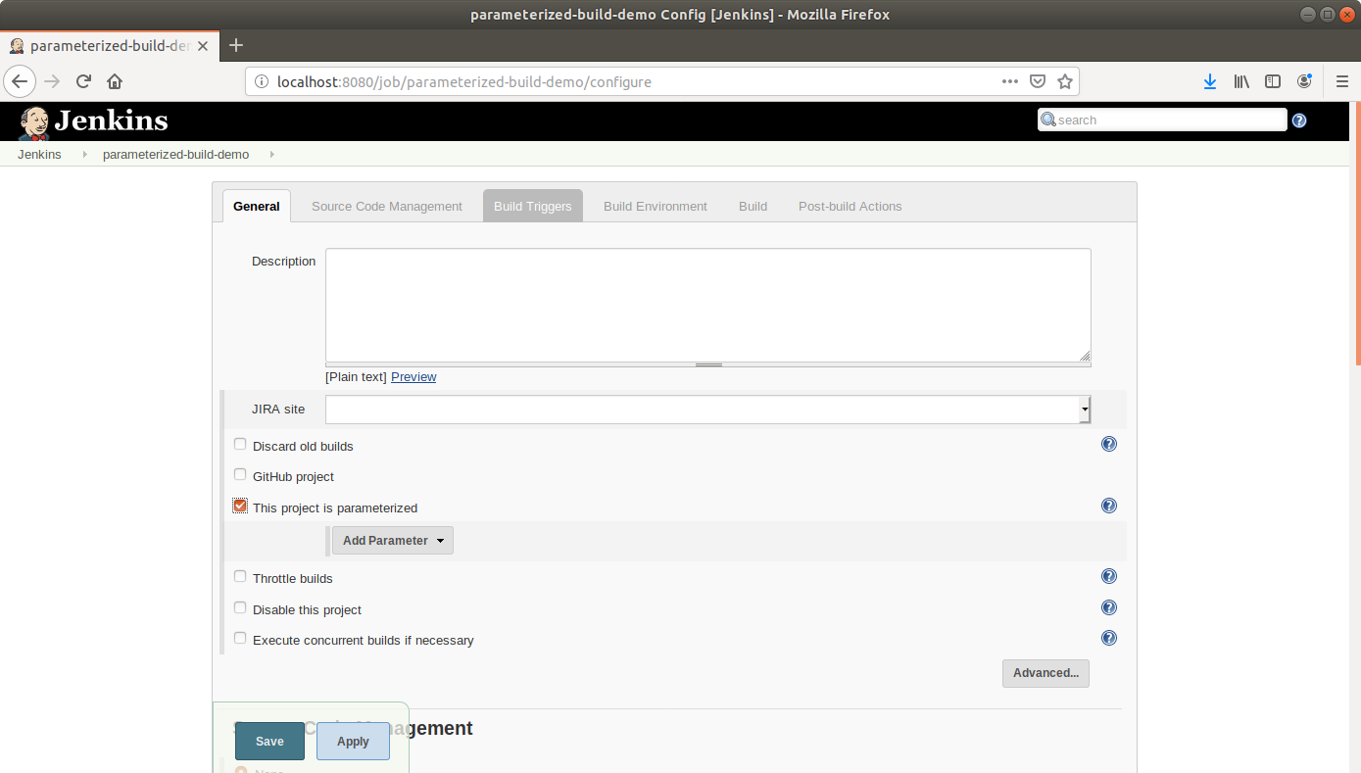

* From the drop-down menu, select ***String parameter***.
* Name the parameter as ***DIR_PATH*** and enter the *Default Value*, the path to the input files.

Name: **DIR_PATH**

Default value: **/home/labuser/input/*.txt**

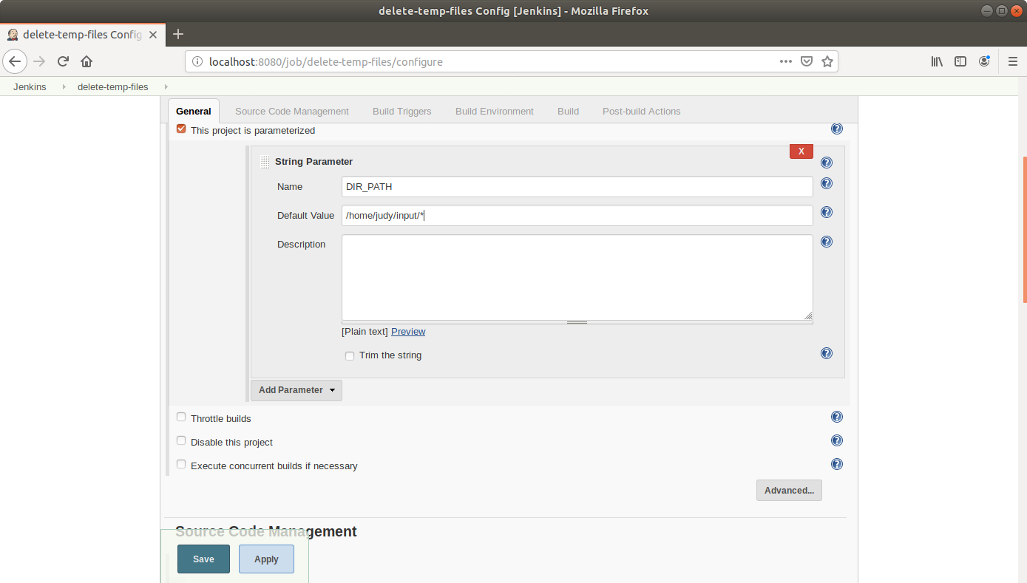

* Scroll down to the***Build* section** and click on ***Add build step***.
* Select***Execute Shell Command***from the drop down.

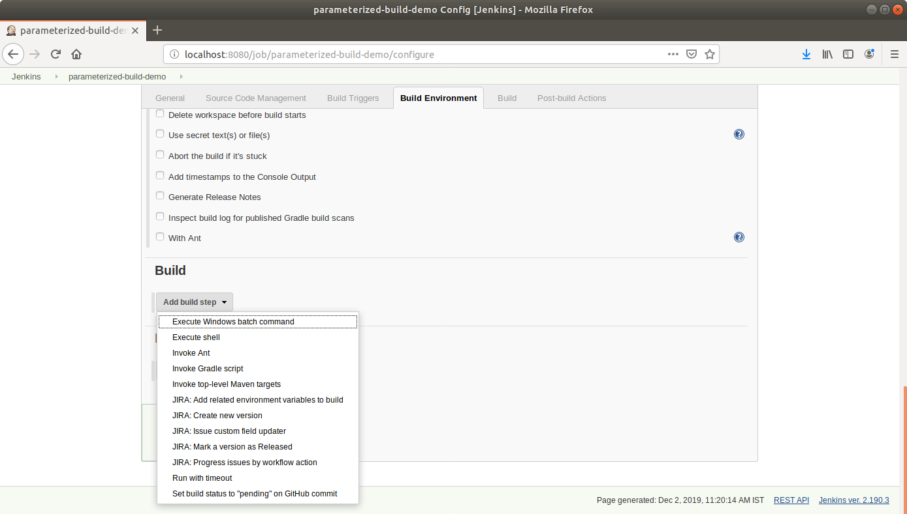

* In the text input area, enter the below text:

**export DIR_PATH**

**sudo rm -f $DIR_PATH**

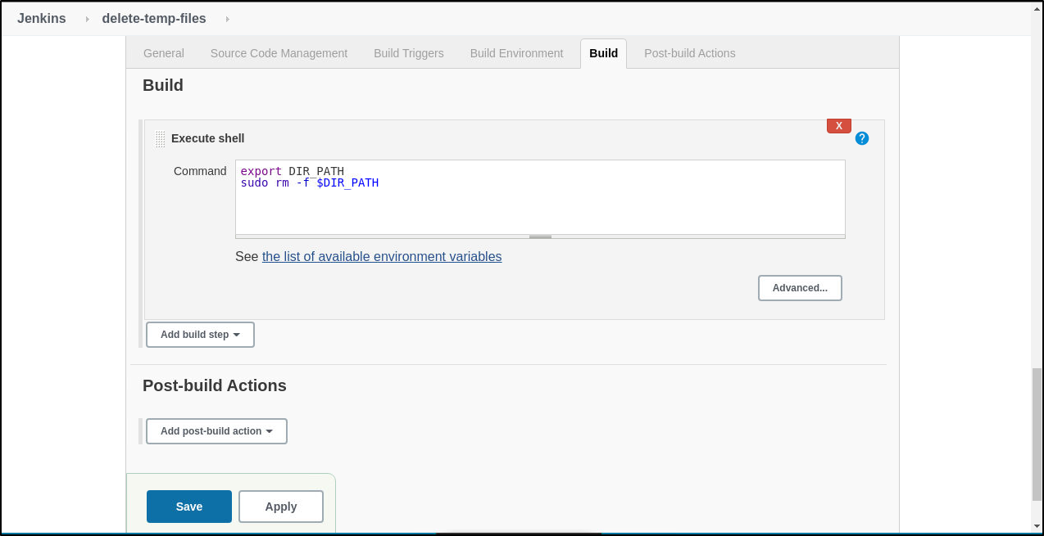

* Click **Save**.

**Step 4:** Creating a parameterized build job in Jenkins to categorize recipes and trigger delete job

* Go to Jenkins **dashboard**.
* Click on ***New Item***.
* Enter a **name** for your build job.
* Select ***Freestyle project***as the build job type.

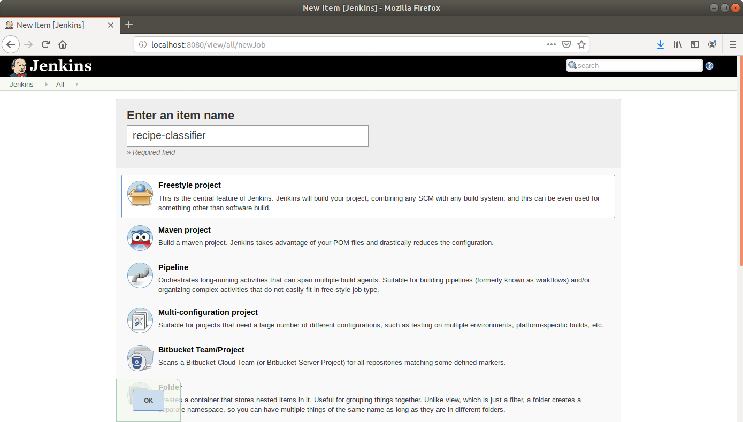

* Click **OK**.
* On the configuration page, select the checkbox next to text that states,***This project is parameterized*.**
* Click on the ***Add parameter*** button.



* From the drop-down menu, select ***String parameter***.
* Name the parameter as ***FILE_PATH*** and select the checkbox that says, ***Trim the string***.

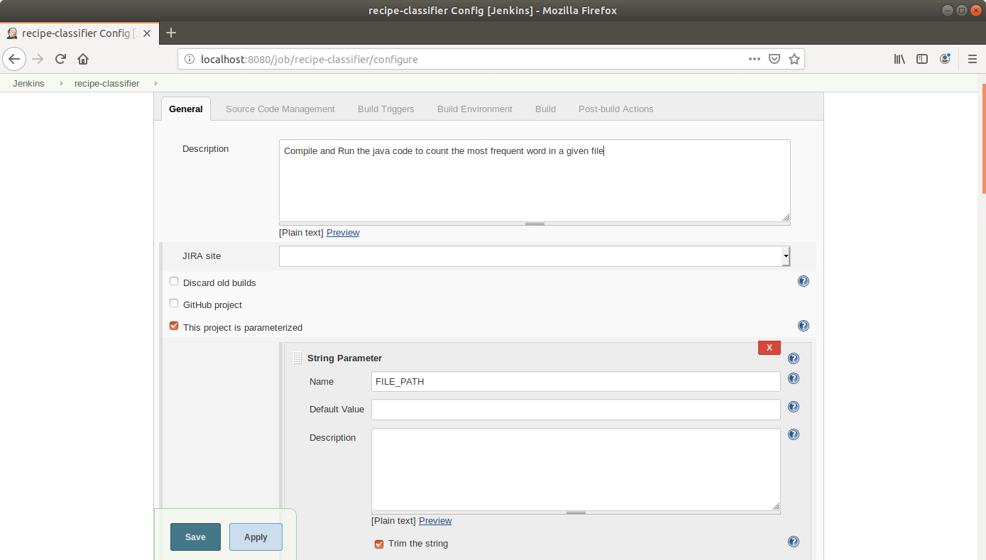

* Scroll down to the Source Code Management section and select ***Git***.
* Enter the link to the repository in the field that appears.

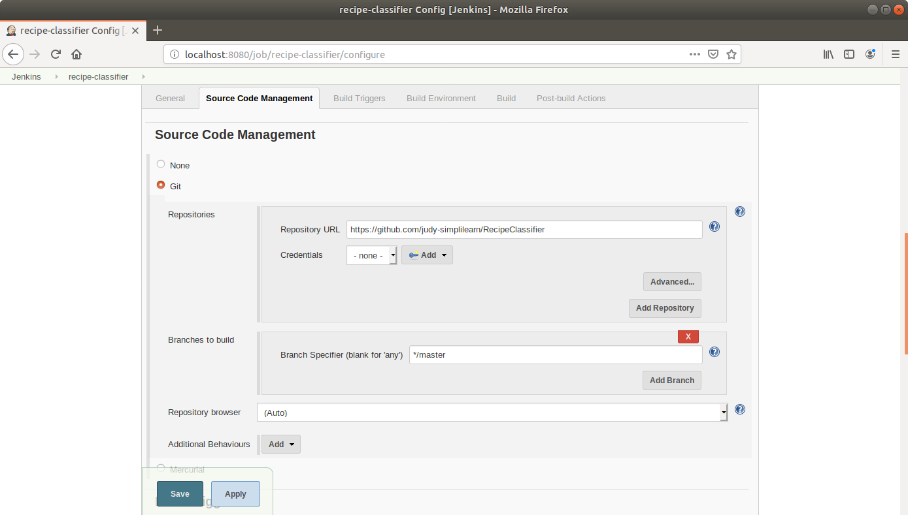

* Under Build Triggers section select **Trigger builds remotely** and type **Sam** as the token value.

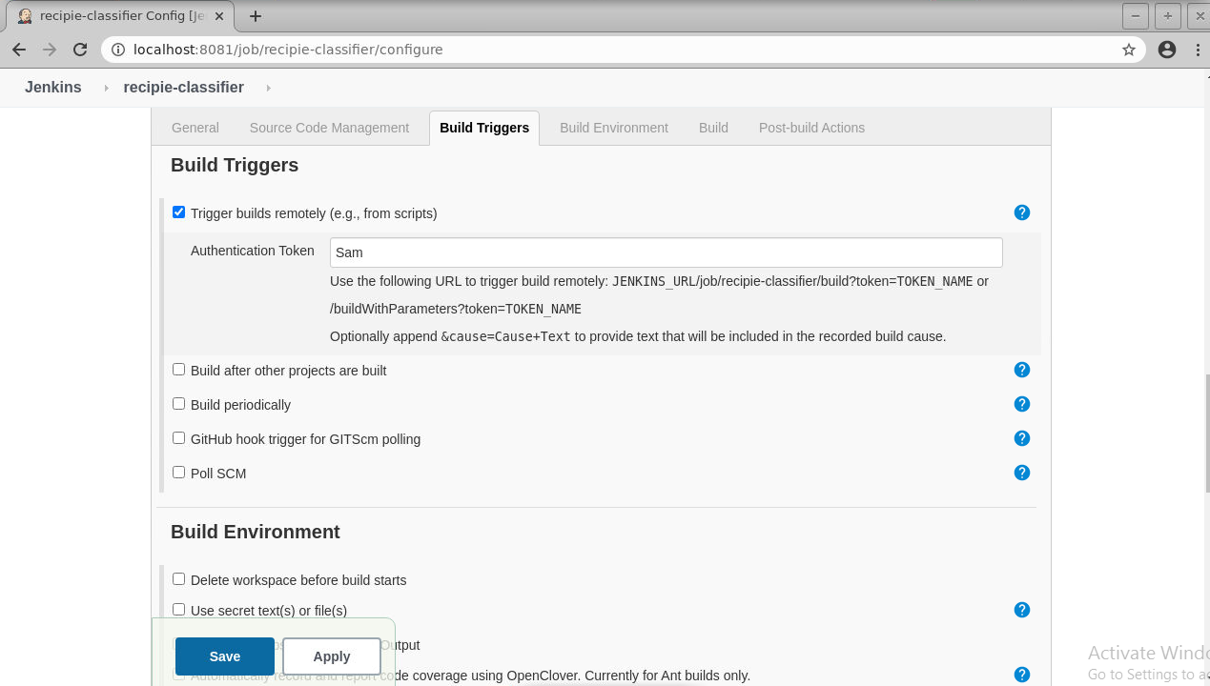

* Scroll down to the***Build* section** and click on ***Add build step***.
* Select***Execute Shell Command***from the drop down.



* In the text input area, enter the below text:

**javac Test.java**

**java Test${FILE_PATH}**

* Scroll down to the ***Post-build Actions*** tab and click on the ***Add post-build action*** button.
* From the drop down, select ***Build other projects****.*

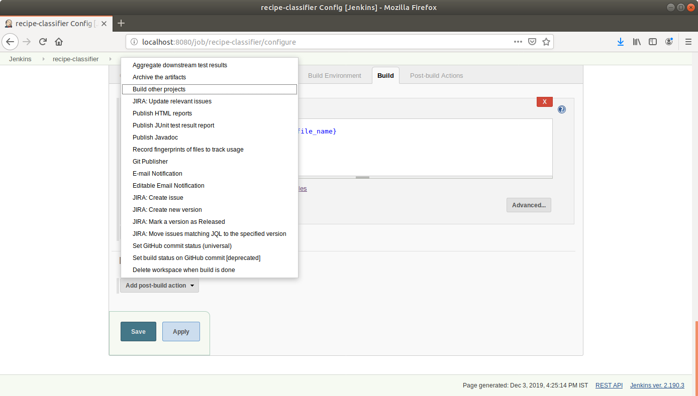

* Enter the **name** of the project to be triggered post-build in the textbox that appears.

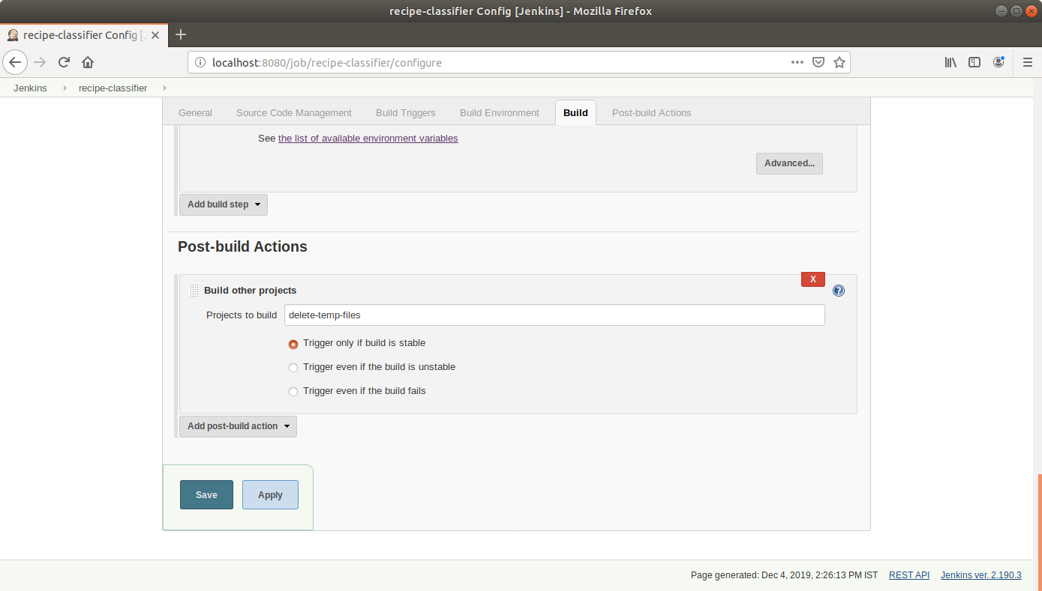

* Click **Save**.

**Step 5:** Triggering a parameterized build remotely

* Copy the URL to the job from the project window.

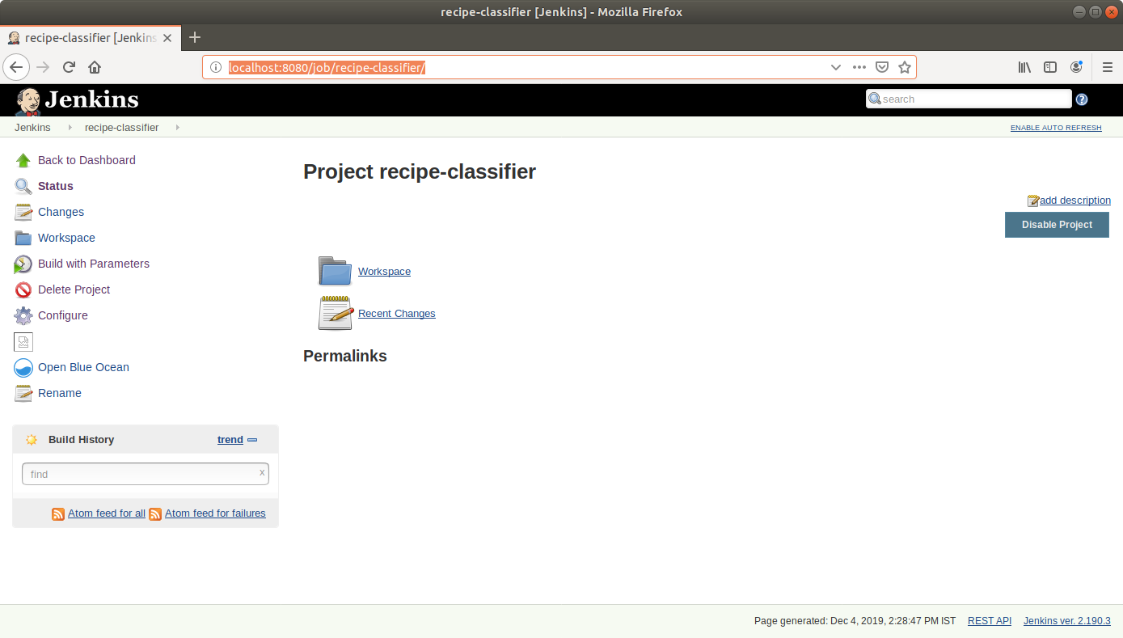

* Open the terminal.
* Suffix the parameter and its value to the URL copied in the previous step and send a *GET* request using *Curl*:

**curl -X GET <YourJenkinsJobURL>/buildWithParameters?token=Sam**

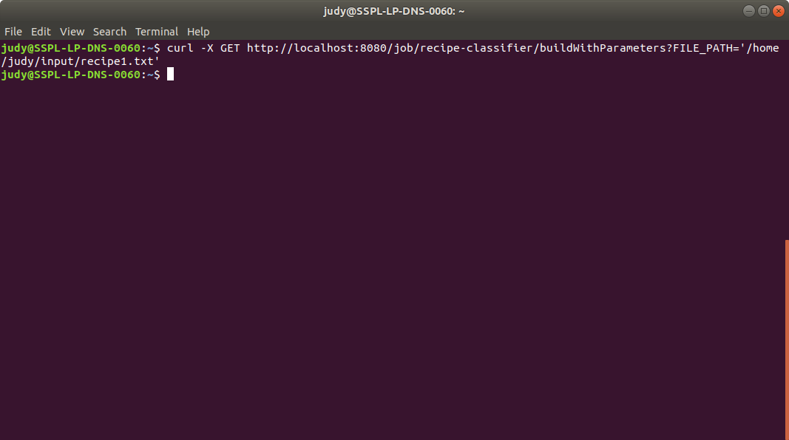

* Open the job in the **Jenkins UI**.
* Click on the ***Build History***to view the build results.
* Click on the ***Console Output*** to view the build logs.

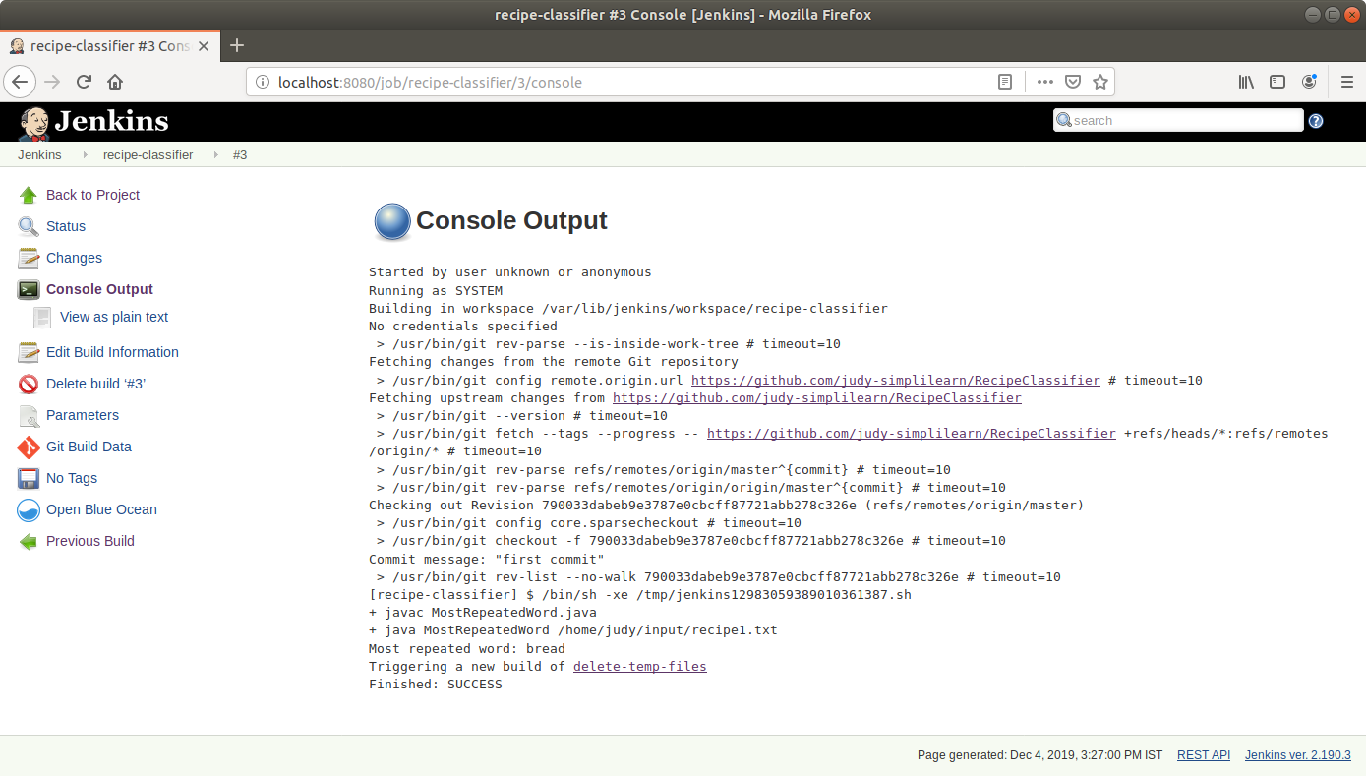

* Open the **newly triggered job** name in the logs.
* Click on the ***Build History***to view the build results for the post-build job.
* Click on the ***Console Output*** to view the build logs.

